PRESS RELEASE

COMMUNICATIONS AND MEDIA TEAM OF THE 2023 ASEAN SUMMIT

No.14/SP/TKM-ASEAN2023/ENG/5/2023

First Quarter Achievements of Indonesia's ASEAN Chairmanship 2023

Jakarta, 1 May 2023 – Indonesia has ensured that it will oversee the achievements of three main pillars in its ASEAN 2023 Chairmanship. This was confirmed by Ministry of Foreign Affairs Spokesperson Teuku Faizasyah, Monday (1/5/2023).

For the first pillar, ASEAN Matters, Indonesia has prepared a grand vision of ASEAN 2045 as well as a discussion process on the draft ASEAN Leaders Declaration to strengthen ASEAN's institutional capacity and effectiveness.

"The outcome is expected to be adopted during the 42nd ASEAN Summit, 9 to 11 May 2023 in Labuan Bajo, West Manggarai, East Nusa Tenggara (NTT)," Faizasyah said.

Regarding the first pillar, Indonesian Foreign Minister Retno Marsudi, during the first quarter briefing of the ASEAN Chairmanship in April 2023, even emphasised a number of issues that must continue to be pushed in the discussion, namely the negotiation of the Code of Conduct (COC) text, eradication of Trafficking in Persons, strengthening the institutionalisation of the Human Rights Dialogue in ASEAN, drafting the Timor Leste membership Roadmap, and signing the Southeast Asia Nuclear Weapon-Free Zone (SEANWFZ) Protocol.

On the second pillar, Epicentrum of Growth, priorities such as strengthening the health architecture through the One Health Initiative, strengthening food security and strengthening energy security, including through the development of an electric vehicle ecosystem, were discussed. The commitment to use ASEAN currencies in trade transactions and connectivity of payment mechanisms in the region has also been agreed to strengthen regional financial stability.

Meanwhile, on the third pillar, namely the implementation of ASEAN Outlook on the Indo-Pacific (AOIP), the Minister of Foreign Affairs also emphasised the strengthening of concrete AOIP cooperation based on the principles of inclusiveness, economic cooperation, and economic development. To that end, Indonesia will organise a flagship event, the ASEAN-Indo-Pacific Forum.

Complementing these three pillars, a number of important meetings have also been held in the last four months, such as the ASEAN Foreign Ministers' Retreat in Jakarta which was held on 1-4 February 2023. Also, the ASEAN Tourism Ministers' Meeting in Yogyakarta on 2-5 February 2023 and ASEAN SOM and Related Meetings in Jakarta on 6-8 March 2023 were held.

A meeting was held between ASEAN economic ministers in the ASEAN Economic Ministers' (AEM) Retreat on 20-22 March 2023 in Magelang, Central Java, and also the ASEAN Finance Ministers & Central Bank Governors' Meeting on 28-31 March 2023 in Bali.

Not only that, the ASEAN Youth Dialogue on Development for Sustainable Development Goals on 11-13 April 2023 was also a forum to exchange ideas and formulate recommendations related to digital development in Southeast Asia by around 60 youth from ASEAN and Timor Leste. The recommendations will then be submitted to ASEAN Leaders at the 42nd ASEAN Summit in Labuan Bajo.

Through the theme of the ASEAN Chairmanship: "ASEAN Matters: Epicentrum of Growth", Indonesia is determined to direct ASEAN cooperation in 2023 to continue and strengthen ASEAN's relevance in responding to regional and global challenges, as well as strengthen ASEAN's position as the epicentrum of regional economic growth, for the prosperity of the people of ASEAN. (Ministry of Foreign Affairs/TR/Elvira)

***

For more information, please contact the following:

Director General for Information and Public Diplomacy of the Ministry of Foreign Affairs - Teuku Faizasyah (08121134275)

Get more information at http://asean2023.id and https://infopublik.id

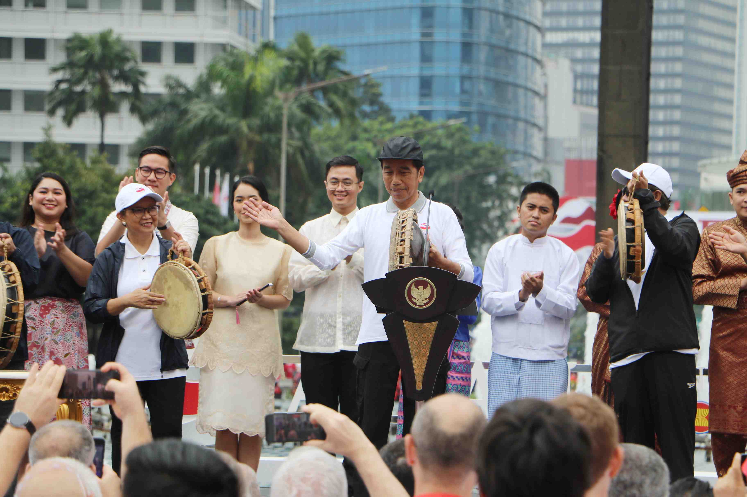

President Joko Widodo (centre) playing the rebana to kick off Indonesia’s 2023 ASEAN Chairmanship at the Hotel Indonesia Roundabout, Sunday (29/2/2023). President Joko Widodo is optimistic that under Indonesia’s leadership, ASEAN will continue to grow and greatly contribute to the region and the world. The kick off marked the start of Indonesia’s Chairmanship of ASEAN in 2023.

